QSR’s Breakout Brand of 2021: Slim Chickens Hits Another Gear

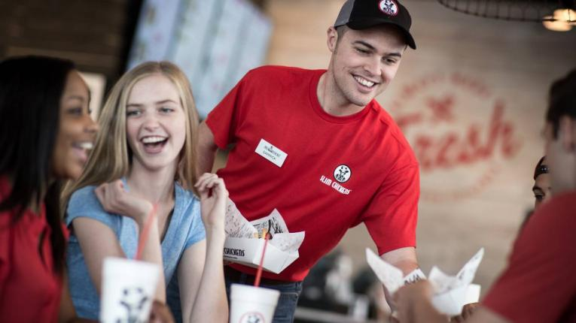
January 1, 2022

In what’s become perhaps the most-bursting world of quick service, Slim Chickens has had no trouble standing out.

For Slim Chickens, the bar was set when franchising began nearly a decade ago—reach 600 locations by 2025.

The proclamation was injected with more life after an equity investment in 2019 from 10 Point Capital, a firm that also backs fast-growing Walk-On’s, which saw its unit count expand by nearly 40 percent in 2020, and Tropical Smoothie Cafe, a chain that recently exceeded 1,000 stores.

“We really were able to speed up franchising and speed up franchise development,” says Tom Gordon, who co-founded the chain in 2003 with Greg Smart. “It allowed us to recruit more, hire more people, not be as constrained budget-wise when it came to payroll and executives and hiring and travel, and allowed us to really start moving around the country and doing the things we needed to do as a franchisor to really grow the business.”

But as Gordon explains, 150-unit Slim Chickens—QSR’s Breakout Brand of the Year for 2021—already “had a good fire going” before 10 Point Capital entered the business. The investment was really just a matter of pouring gasoline on the flames.

The Fayetteville, Arkansas-based fast casual grew from a little more than a dozen units in 2014 to north of 80 when the investment occurred. In 2015, the brand had 46 franchise commitments, and that expanded to 112, 180, 235, 334, and 477 over the next five years. Slim Chickens finished 2021 with more than 750 commitments and over 50 franchise groups.

For Slim Chickens, the bar was set when franchising began nearly a decade ago—reach 600 locations by 2025.

The proclamation was injected with more life after an equity investment in 2019 from 10 Point Capital, a firm that also backs fast-growing Walk-On’s, which saw its unit count expand by nearly 40 percent in 2020, and Tropical Smoothie Cafe, a chain that recently exceeded 1,000 stores.

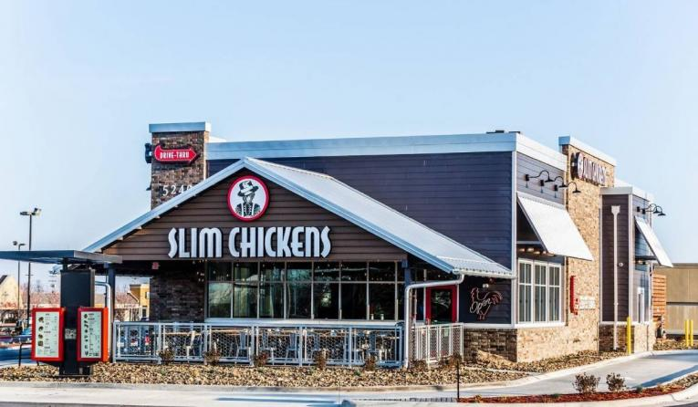
“We really were able to speed up franchising and speed up franchise development,” says Tom Gordon, who co-founded the chain in 2003 with Greg Smart. “It allowed us to recruit more, hire more people, not be as constrained budget-wise when it came to payroll and executives and hiring and travel, and allowed us to really start moving around the country and doing the things we needed to do as a franchisor to really grow the business.”

But as Gordon explains, 150-unit Slim Chickens—QSR’s Breakout Brand of the Year for 2021—already “had a good fire going” before 10 Point Capital entered the business. The investment was really just a matter of pouring gasoline on the flames.

The Fayetteville, Arkansas-based fast casual grew from a little more than a dozen units in 2014 to north of 80 when the investment occurred. In 2015, the brand had 46 franchise commitments, and that expanded to 112, 180, 235, 334, and 477 over the next five years. Slim Chickens finished 2021 with more than 750 commitments and over 50 franchise groups.

Rothschild and Gordon essentially handled all of the franchising business from 2013–2018, which resulted in about 200 deals being signed, including a couple internationally. Then Jackie Lobdell entered the fray as executive director of franchise development, with more than 25 years of sales professional experience, including Focus Brands, where she helped McAlister’s Deli expand to more than 400 stores across 28 states. From 2013 to present, workforce at the support center grew from a handful to over 40 individuals.

Now when Slim Chickens hosts Discovery Days, potential franchisees take a look at the systems and are taken aback at what Rothschild calls a “full-service franchisor.” That means training, operations, construction, facility design, marketing, purchasing, financial planning, and analysis.

These operators are well-funded and typically mid-to-large franchisees of other brands looking to complement their portfolio with another chicken brand. A good example is Barnett Management Company, an Arizona-based franchisee that operates more than 50 Burger King stores. The operators signed an agreement to open 32 Slim Chickens restaurants over the next decade.

“They see the success that the brand is having and what we have to offer not only to consumers, but the way that we support the franchisees with all the systems and processes and tools that we provide,” Rothschild says. “I think we’re able to attract some really high-caliber franchise talent that has come into this organization and not only joined us, but helped make us better.”

“We really admire entrepreneurs,” he adds. “We listen to what they have to say for the betterment of the brand and the system. I think if you put all that together that’s why we’re seeing the ramp up and growth and the addition of all these new franchisees coming into the brand.”

Similar to many up-and-coming chains, Gordon says, Slim Chickens restaurants require “good-looking, sexy retail” supported by housing stock and other traffic attractors like hospitals and malls. Typically, stores are between 2,400–2,800 square feet and adaptable to patios and unenclosed or enclosed kitchens.

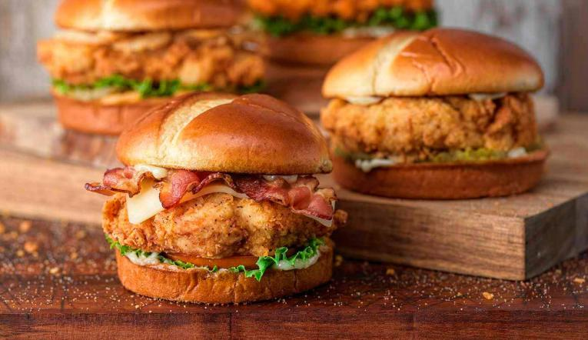
He estimates 90 percent of the footprint is standalone drive-thru units, but there are some anomalies—endcaps, inline locations on college campuses, and military bases. The brand is no stranger to conversions, either, an important skill set given how many restaurants across the industry closed permanently during the pandemic.

The markets with the most opportunity for development include the Upper Midwest and Northeast, like Minnesota, Michigan, Ohio, Pennsylvania, New England, and West Virginia.
As Slim Chickens’ unit count continues to rise, onlookers shouldn’t expect the footprint to account for ghost kitchens or virtual brands. Gordon says ghost kitchens skyrocketed during COVID to leverage inventory and labor that weren’t being used effectively. However, the chicken fast casual remained busy throughout the pandemic, and hasn’t had a need for either innovation.

A minimal number of stores closed, and drive-thru, curbside, and delivery continue to be fruitful.

“So rather than try to create a new brand out of kitchens that were already busy, we tried to focus and make sure that the drive-thru experiences was good, curbside experience was good,” Gordon says. “We worked on the timing, speed and efficiency, and packaging around our delivery business with the delivery partners that everyone is aware of. We just try to focus on those channels and then as the dining rooms have come back, we’ve layered those back in.”
Heading into 2020, the gameplan was to open about 25 stores, but the chain still finished with 19 debuts. And the ones that didn’t open simply slid into the next year. Gordon says after the “scary moments” of Q1 2020, Slim Chickens got back on track. When COVID first hit, leadership quickly gathered everyone virtually and emphasized there would be no furloughs.

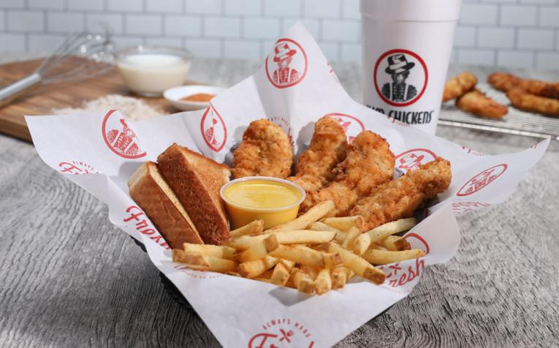
In fact, considering what occurred in 2020 and 2021, the brand is at—or even ahead—of its preferred timeline. To Rothschild, experiences during the pandemic demonstrated the confidence operators had in Slim Chickens.

“I think the franchisees, along with us, did a great job of figuring out where we could get momentum,” Rothschild says. “We can make progress where we can get restaurants open, and the support team really worked diligently to make sure that we could get the best results we could with the situation that we were dealing with.”

As the brand faced macroeconomic headwinds like supply chain stoppages, Slim Chickens urged franchisees to be proactive and double timelines for equipment and construction materials. Leadership helped operators schedule restaurant opening dates, and then worked backward to deliver appropriate guidance in terms of ordering items. Gordon says some things “slip around a little bit,” but he adds most franchisees are exactly where they want to be.

The other notable headache, labor, hasn’t been too much of an issue, Rothschild says. Restaurants usually hire 90–100 people, and there are challenges occasionally, but for the most part, managers are able to staff appropriately and retain workers.

A significant reason for that is partnering with the right franchisees. For instance, Preferred Restaurant Group, which has more than a dozen Taco John’s restaurants and owns development rights to Slim Chickens franchise stores in North Dakota and Montana, placed general managers in a position to earn six figures, increased starting wages, and instituted a $5 per hour bump for those working past 10 p.m.

“I go around and talk to all the employees at the restaurant openings and ask them why they work here or if they’ve had other jobs, and there’s this aura around Slim Chickens that allows us the opportunity to hire and retain a staff,” Rothschild says. “Now, not saying we’re Pollyanna here and we’re not having staffing challenges, but if you want to connect new restaurant openings to staffing, we’re able to get these things staffed and get them open.”

Gordon says much of Slim Chicken’s success is listening to what operators hate about franchising—i.e. non-communicative, lack of proper investment in profitability, unrealistic outlooks—and simply doing the opposite.

That mission is upheld by a C-suite that’s stayed together for a number of years, including eight years from Rothschild, 10 years from CFO Seth Jensen, and five from CMO Chris Allison.
It’s more than enough fuel for Gordon and his team to continue believing in the 600-unit goal that was proposed all those years ago.

“We all own the business together, so it’s not like we’re leaving to go do something else,” Gordon says. “ … [Franchisees] can believe in us. We’re transparent, honest, and really have the interest of our franchisees at heart. As you see the growth happening, we’ll get to that 600 number on or about the place that we anticipated.”

Link: https://bit.ly/3zrSGU6

